Analysis of the 15 images we have of trauma

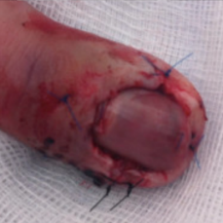 non-serious#3 **Confidences:**normal = 98%; non-serious = 0%; warrants second opinion = 1%;   
The nail's condition is normal with confidence score of 98%.  
The confidence score for it warranting a second opinion is 1%. [image source](http://localhost:8080/ai/onyx/images/trauma/nail%20trauma%205.png)×

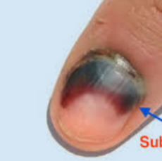 non-serious#7 **Confidences:**normal = 31%; non-serious = 4%; warrants second opinion = 66%;   
It is most likely that the nail indicates something that warrants a second opinion and you should seek medical advice. (Confidence score is 66%) [image source](http://localhost:8080/ai/onyx/images/trauma/nail%20trauma%209.png)×

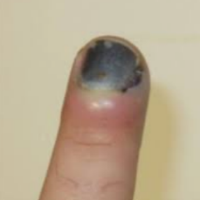 non-serious#4 **Confidences:**normal = 73%; non-serious = 11%; warrants second opinion = 16%;   
The nail's condition is normal with confidence score of 73%.  
The confidence score for it warranting a second opinion is 16%. [image source](http://localhost:8080/ai/onyx/images/trauma/nail%20trauma%206.png)×

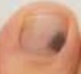 non-serious#9 **Confidences:**normal = 1%; non-serious = 12%; warrants second opinion = 87%;   
It is most likely that the nail indicates something that warrants a second opinion and you should seek medical advice. (Confidence score is 87%) [image source](http://localhost:8080/ai/onyx/images/trauma/nail%20trauma%2011.png)×

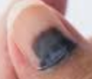 non-serious#5 **Confidences:**normal = 5%; non-serious = 70%; warrants second opinion = 24%;   
It might be warrant a second opinion (confidence score is 24%)  [image source](http://localhost:8080/ai/onyx/images/trauma/nail%20trauma%207.png)×

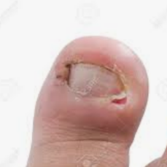 non-serious#8 **Confidences:**normal = 10%; non-serious = 80%; warrants second opinion = 10%;   
The nail's condition is non-serious with confidence score of 80%.  
Otherwise it is normal with confidence score of 10%. [image source](http://localhost:8080/ai/onyx/images/trauma/nail%20trauma%2010.png)×

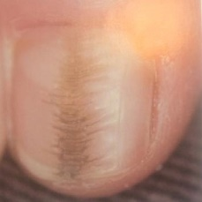 non-serious#12 **Confidences:**normal = 13%; non-serious = 84%; warrants second opinion = 3%;   
The nail's condition is non-serious with confidence score of 84%.  
Otherwise it is normal with confidence score of 13%. [image source](http://localhost:8080/ai/onyx/images/Nail%20Images%20from%20Library%20book/minor%20trauma%20nail%201%20habit%20tic%20deformity-b.jpg)×

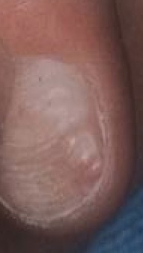 non-serious#13 **Confidences:**normal = 5%; non-serious = 95%; warrants second opinion = 0%;   
The nail's condition is non-serious with confidence score of 95%.  
Otherwise it is normal with confidence score of 5%. [image source](http://localhost:8080/ai/onyx/images/Nail%20Images%20from%20Library%20book/minor%20trauma%20nail%202%20habit%20tic%20deformity.jpg)×

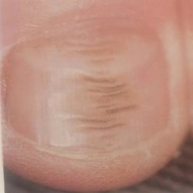 non-serious#11 **Confidences:**normal = 2%; non-serious = 98%; warrants second opinion = 0%;   
The nail's condition is non-serious with confidence score of 98%.  
Otherwise it is normal with confidence score of 2%. [image source](http://localhost:8080/ai/onyx/images/Nail%20Images%20from%20Library%20book/minor%20trauma%20nail%201%20habit%20tic%20deformity-a.jpg)×

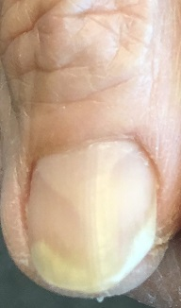 non-serious#14 **Confidences:**normal = 1%; non-serious = 98%; warrants second opinion = 1%;   
The nail's condition is non-serious with confidence score of 98%.  
Otherwise it is normal with confidence score of 1%. [image source](http://localhost:8080/ai/onyx/images/trauma/Karen%20IMG_1621-a.jpg)×

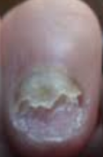 non-serious#2 **Confidences:**normal = 0%; non-serious = 100%; warrants second opinion = 0%;   
The nail's condition is non-serious with confidence score of 100%. [image source](http://localhost:8080/ai/onyx/images/trauma/nail%20trauma%204.png)×

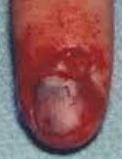 non-serious#1 **Confidences:**normal = 0%; non-serious = 100%; warrants second opinion = 0%;   
The nail's condition is non-serious with confidence score of 100%. [image source](http://localhost:8080/ai/onyx/images/trauma/nail%20trauma%203.png)×

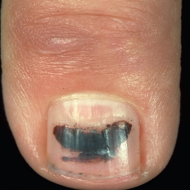 non-serious#10 **Confidences:**normal = 0%; non-serious = 100%; warrants second opinion = 0%;   
The nail's condition is non-serious with confidence score of 100%. [image source](http://localhost:8080/ai/onyx/images/trauma/nail%20trauma%2012.png)×

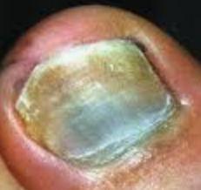 non-serious#6 **Confidences:**normal = 0%; non-serious = 100%; warrants second opinion = 0%;   
The nail's condition is non-serious with confidence score of 100%. [image source](http://localhost:8080/ai/onyx/images/trauma/nail%20trauma%208.png)×